Mutchumari Chandrsekhar Reddy
AP25110010976

1. Implementation of finding the maximum and minimum element using divide and conquer strategy.
Program:
#include <stdio.h>
void maxmin(int a[], int low, int high, int *max, int *min) { int mid, max1, min1, max2, min2;
if (low == high)
{
*max = *min = a[low];
return;
}
if (high == low + 1)
{
if (a[low] > a[high])
{
*max = a[low];
*min = a[high];
}
else
{
*max = a[high];
*min = a[low];
}
return;
}
mid = (low + high) / 2;
maxmin(a, low, mid, &max1, &min1);
maxmin(a, mid + 1, high, &max2, &min2);
*max = max1 > max2 ? max1 : max2;
*min = min1 < min2 ? min1 : min2;
}
int main() { int a[100], n, i, max, min;
printf("Enter number of elements: ");
scanf("%d", &n);
printf("Enter elements: ");
for (i = 0; i < n; i++)
scanf("%d", &a[i]);
maxmin(a, 0, n - 1, &max, &min);
printf("Maximum element = %d\n", max);
printf("Minimum element = %d\n", min);
return 0;
}
Terminal Process:
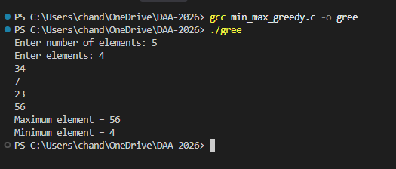

2. Divide and conquer: Implementation of maximum-subarray problem.
Program:
#include <stdio.h>
int max(int a, int b)
{
return a > b ? a : b;
}
int maxCrossingSum(int a[], int low, int mid, int high)
{
int sum = 0, leftSum = -999999, rightSum = -999999;
int i;
for (i = mid; i >= low; i--)
{
sum += a[i];
if (sum > leftSum)
leftSum = sum;
}
sum = 0;
for (i = mid + 1; i <= high; i++)
{
sum += a[i];
if (sum > rightSum)
rightSum = sum;
}
return leftSum + rightSum;
}

int maxSubarray(int a[], int low, int high)
{ int mid, left, right, cross;
if (low == high)
return a[low];
mid = (low + high) / 2;
left = maxSubarray(a, low, mid);
right = maxSubarray(a, mid + 1, high);
cross = maxCrossingSum(a, low, mid, high);
return max(max(left, right), cross);
}
int main()
{
int a[100], n, i, result;
printf("Enter number of elements: ");
scanf("%d", &n);
printf("Enter elements: ");
for (i = 0; i < n; i++)
scanf("%d", &a[i]);
result = maxSubarray(a, 0, n - 1);
printf("Maximum subarray sum = %d\n", result);
return 0;
}
Terminal Process:
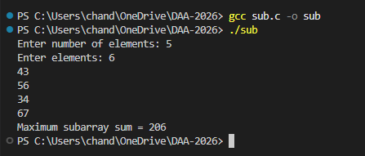

3. Divide and conquer: Implementation of Strassen’s algorithm for matrix multiplication.
Program:
#include <stdio.h>
void strassen(int A[2][2], int B[2][2], int C[2][2])
{
int M1, M2, M3, M4, M5, M6, M7;
M1 = (A[0][0] + A[1][1]) * (B[0][0] + B[1][1]);
M2 = (A[1][0] + A[1][1]) * B[0][0];
M3 = A[0][0] * (B[0][1] - B[1][1]);
M4 = A[1][1] * (B[1][0] - B[0][0]);
M5 = (A[0][0] + A[0][1]) * B[1][1];
M6 = (A[1][0] - A[0][0]) * (B[0][0] + B[0][1]);
M7 = (A[0][1] - A[1][1]) * (B[1][0] + B[1][1]);
C[0][0] = M1 + M4 - M5 + M7;
C[0][1] = M3 + M5;
C[1][0] = M2 + M4;
C[1][1] = M1 - M2 + M3 + M6;
}
int main()
{
int A[2][2], B[2][2], C[2][2];
int i, j;
printf("Enter first 2x2 matrix:\n");
for (i = 0; i < 2; i++)
for (j = 0; j < 2; j++)
scanf("%d", &A[i][j]);
printf("Enter second 2x2 matrix:\n");
for (i = 0; i < 2; i++)
for (j = 0; j < 2; j++)
scanf("%d", &B[i][j]);
strassen(A, B, C);
printf("Resultant matrix:\n");
for (i = 0; i < 2; i++)
{
for (j = 0; j < 2; j++)
printf("%d ", C[i][j]);
printf("\n");
}
return 0;
}
Terminal process:
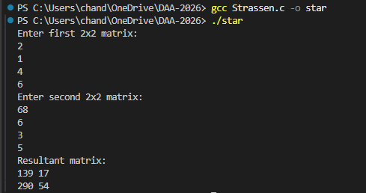
4. Greedy Approach: Implementation of Fractional Knapsack.
Program:
#include <stdio.h>
struct Item
{
int weight;
int value;
float ratio;
};
int main()
{
struct Item item[100], temp;
int n, capacity, i, j;
float total = 0;
printf("Enter number of items: ");
scanf("%d", &n);
printf("Enter weight and value of each item:\n");
for (i = 0; i < n; i++)
{
scanf("%d %d", &item[i].weight, &item[i].value);
item[i].ratio = (float)item[i].value / item[i].weight;
}
printf("Enter capacity of knapsack: ");
scanf("%d", &capacity);
for (i = 0; i < n - 1; i++)
{
for (j = i + 1; j < n; j++)
{
if (item[i].ratio < item[j].ratio)
{
temp = item[i];
item[i] = item[j];
item[j] = temp;
}
}
}
for (i = 0; i < n; i++)
{
if (capacity >= item[i].weight)
{
capacity -= item[i].weight;
total += item[i].value;
}
else
{
total += item[i].ratio * capacity;
break;
}
}
printf("Maximum profit = %.2f\n", total);
return 0;
}
Terminal process:
